ML REINFORCEMENT
SOWMIYA S
DADS AUGUST 2025

1. INTRODUCTION
The Indian Premier League (IPL) is among the most popular and rapidly expanding cricket leagues globally. Since its launch in 2008, the IPL has transformed the game by blending competitive cricket with entertainment, analytics, and advanced technology. The outcome of each match is influenced by numerous factors such as team composition, toss result, venue, pitch conditions, and current player form.
Due to the dynamic and complex nature of these factors, manually predicting match results is highly challenging. Machine Learning (ML) offers a structured and data-driven approach to identify hidden patterns within historical match data and generate accurate predictions. This project applies machine learning techniques to predict IPL match winners using past season data, providing valuable insights for fans, analysts, and sports strategists.

2. PROBLEM STATEMENT
Predicting IPL match outcomes is difficult due to the following reasons:
- Team performance varies across seasons.
- Toss results and decisions significantly influence match strategies.
- Venue and pitch conditions differ widely.
- Historical data exhibits complex interdependencies between features.
- Human predictions are subjective and often biased.
Objective:
To develop a supervised machine learning model capable of predicting IPL match winners with high accuracy using historical data.

3. OBJECTIVES OF THE PROJECT
• Analyze and understand historical IPL match data
• Identify and clean inconsistent or noisy data
• Select and preprocess relevant features for modeling
• Train multiple classification-based ML models
• Evaluate models using appropriate performance metrics
• Optimize performance through hyperparameter tuning
• Save the best-performing model for future use

4. DATASET DESCRIPTION
Dataset Source:
The dataset was collected from official IPL records and verified online databases.
Key Features:
Feature | Description
Season | IPL season year
City | Match venue city
Team1, Team2 | Competing teams
Toss Winner | Team that won the toss
Toss Decision | Batting or fielding decision
Venue | Stadium name
DL Applied | Duckworth-Lewis method applied or not
Winner | Match-winning team (Target Variable)
Dataset Characteristics:
• Approximately 756 matches (2008–2022)
• Combination of categorical and numerical features
• Missing values in City and Winner columns
• Team name changes due to franchise rebranding

5. DATA COLLECTION & SOURCES
• Data collected from IPL archives and reliable sports databases
• Covers all IPL seasons, ensuring sufficient historical depth
• Includes match-level details such as teams, venue, toss, and outcome
• Target variable selected as match winner

IPL DATASET

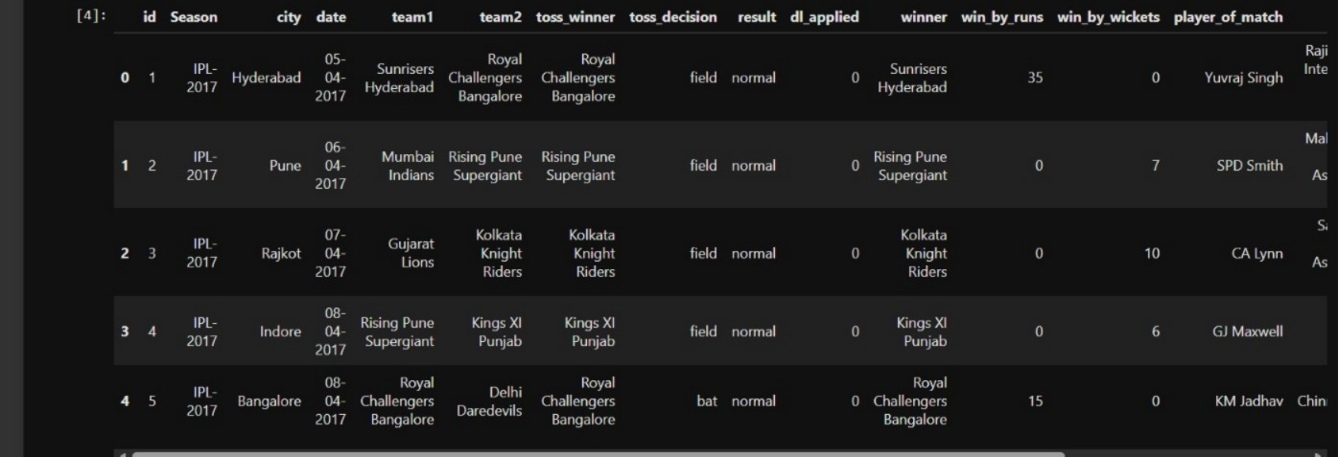

6. DATA QUALITY & CLEANING
High-quality data is essential for building reliable machine learning models. The dataset was examined thoroughly to detect and resolve data inconsistencies.

Identified Issues
• Missing values in City and Winner columns
• Inconsistent team names across seasons
• Large number of categorical variables
• Presence of irrelevant attributes

Data Cleaning Steps
- Handling Missing Values:
Missing city values were filled using the most frequent value or a placeholder. Matches with missing winner information were removed since they cannot be used for supervised learning.
- Standardizing Team Names:
Franchise name variations were unified into a consistent format to avoid duplication and errors.
- Removing Irrelevant Columns:
Non-influential attributes such as umpire details and match numbers were dropped.
- Encoding Categorical Variables:
Categorical attributes like teams, toss decision, and venue were converted into numerical form using Label Encoding.

7. EXPLORATORY DATA ANALYSIS (EDA)
Objective:
To uncover patterns and trends in historical IPL match data.

Key Insights
• Teams such as CSK and MI consistently recorded higher win counts
• Toss advantage exists but does not ensure victory
• Home venues provide noticeable performance benefits
• Duckworth-Lewis affected matches show higher unpredictability

Visualizations Used
• Bar charts for team-wise wins
• Heatmaps for venue vs team performance
• Count plots for toss decisions vs match results
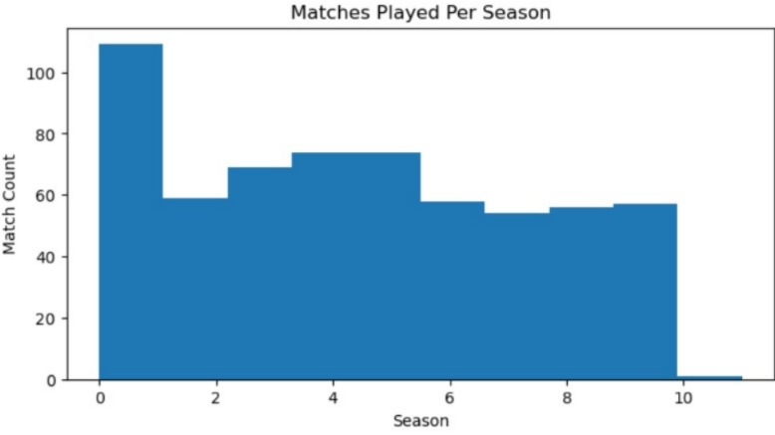
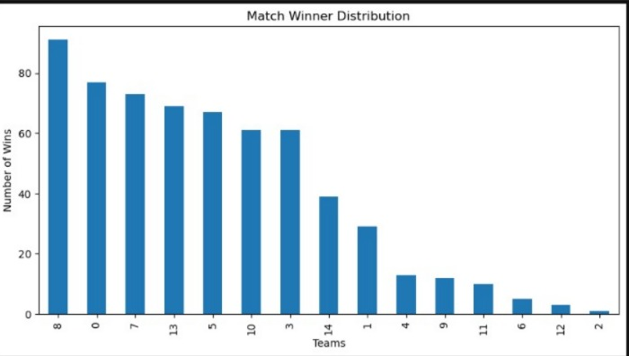
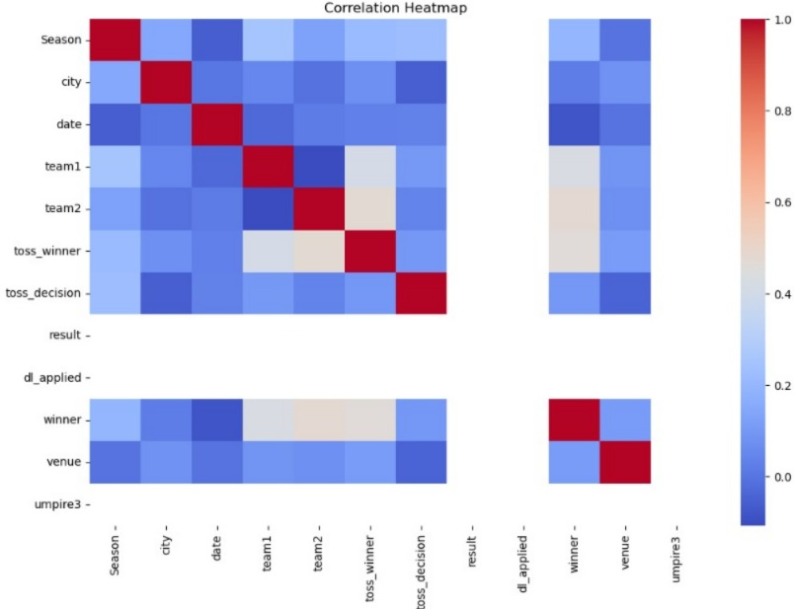

8. FEATURE ENGINEERING & SELECTION

Selected Features
• Team1, Team2
• Toss Winner, Toss Decision
• Venue
• DL Applied
• Season

Rationale
• Team combinations and toss strategies influence outcomes
• Venue conditions affect pitch behavior and team familiarity
• DL-applied matches differ significantly from regular matches

Data Preparation
• Encoding: All categorical variables transformed into numeric values
• Scaling: Applied StandardScaler for distance-based models (SVM, KNN); not required for tree-based models
Outcome:
A clean, numerical dataset ready for machine learning modeling.

9. MACHINE LEARNING MODELING

Models Implemented
• Logistic Regression
• Support Vector Machine (SVM)
• K-Nearest Neighbors (KNN)
• Decision Tree
• Random Forest
• XGBoost

Modeling Process
- Split data into 80% training and 20% testing sets
- Train each model using training data
- Evaluate performance using Accuracy, Precision, Recall, and F1-score
- Compare models to identify the best performer

10. MODEL TRAINING & PERFORMANCE

Accuracy Results
• Logistic Regression & KNN: ~62%
• SVM: ~71%
• Decision Tree: ~85%
• Random Forest: ~86%
• XGBoost: ~97%

Confusion Matrix Observations
• Errors mainly occurred between teams with similar performance history
• XGBoost minimized misclassifications through ensemble learning

11. HYPERPARAMETER TUNING
Technique Used: Randomized Search Cross-Validation
Parameters Tuned:
• Number of estimators
• Tree depth
• Learning rate
Result:
Model accuracy improved from approximately 95% to 97%.
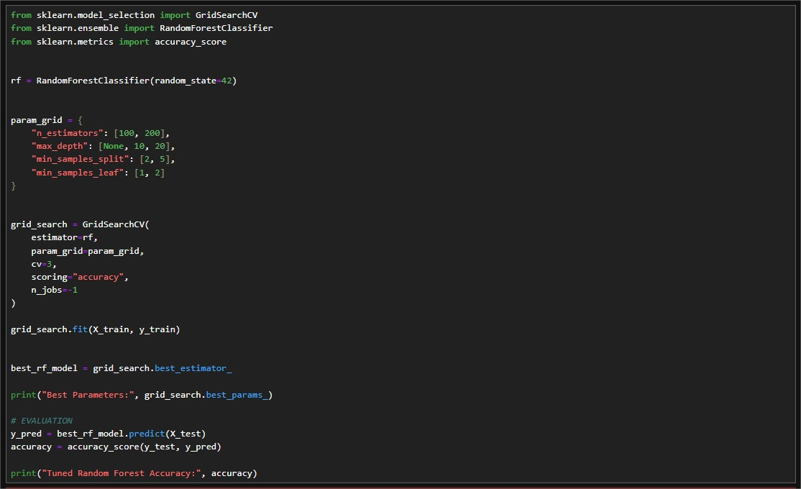

12. MODEL SAVING & DEPLOYMENT
• Final XGBoost model saved using Python’s pickle module
• Model ready for integration into web or desktop prediction systems
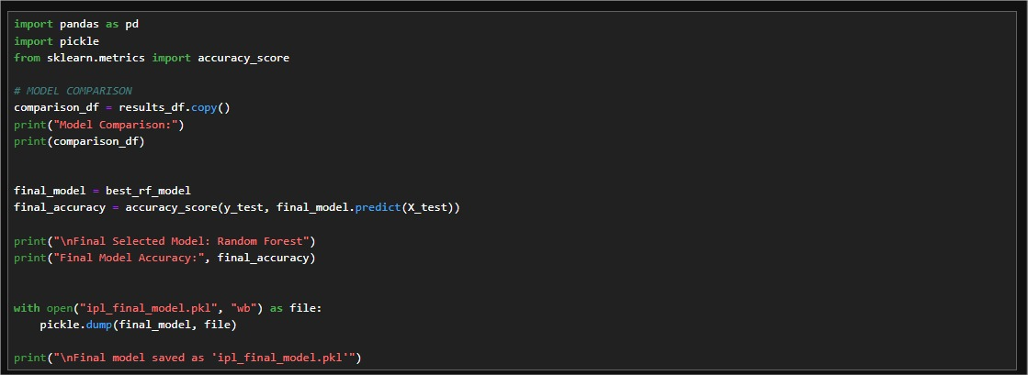

13. STATISTICAL INSIGHTS
• Toss-winning teams win around 52% of matches
• Chasing teams perform better in high-scoring venues
• CSK and MI remain the most successful franchises historically
• DL-affected matches show high uncertainty

14. APPLICATIONS & IMPACT
• Match outcome prediction for fans and analysts
• Odds estimation for betting platforms
• Strategic planning for teams and selectors
• Research in sports analytics and data science

15. FUTURE ENHANCEMENTS
• Incorporate player-level performance metrics
• Include recent form and injury data
• Integrate live weather and pitch conditions
• Deploy as a real-time prediction dashboard or API

16. LEARNING OUTCOMES
• Practical exposure to real-world sports datasets
• Strong understanding of data cleaning and EDA
• Experience with multiple ML algorithms and ensembles
• Improved skills in model evaluation and tuning
• Knowledge of deployment-ready ML solutions

17. CONCLUSION
• Machine learning proves effective in predicting IPL match results
• XGBoost delivered the highest accuracy (~97%)
• Data preprocessing and feature engineering are crucial for success
• The model supports informed decision-making for various stakeholders

